COMPUTERS HARDWARE.

**ANSWER PART A.**

1.Yes,i have.I have a laptop at home.

2.So often,I usually use the computers to learn ,to listen the music,watching videos and many more.

3.The main components and features of my computer are :

a.Proccesor type,Intel Celeron 4th Ge Dual Core N3150

b.Proccesor speed,1.66Hz Chace,Burst Frequency 2.08 GHz

c.Screen size,14 Inch Auto HD 13366 x 768

d.RAM,2GB RAM

e.Hard disk,500GB HDD

f.Disk type,HDD

g.Optical drive,Super-Multi DVD

h.Graphics cards,Integrated Graphic

i.Audio/speaker,Built-in Speakers and Microphone SonicMaster

j.Networking,Intergrated 802.11 b/g/n

k.Webcam,1.7 AMP Megapixel

l.Card reader,SD SDHC

m.Battery,6-Cell Battery 4 hours Backup

n. Product weight(kg),2.0 kg.

o.Keyboard

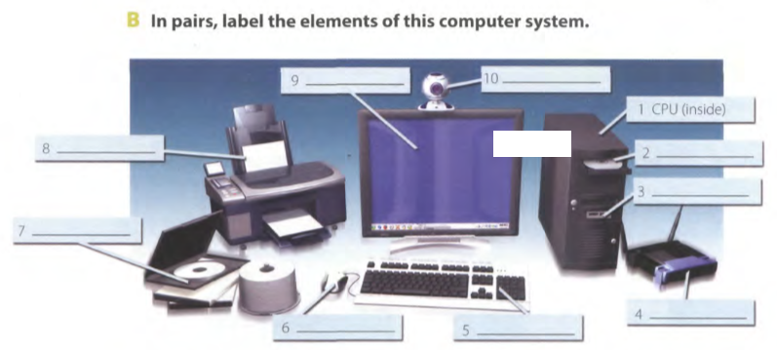

**ANSWER PART B**

1.CPU(Inside)

2.Floppy disk

3.USB port

4.Access point

5.Keyboard

6.Mouse

7.CD room

8.Printer

9.Monitor

10.Webcam

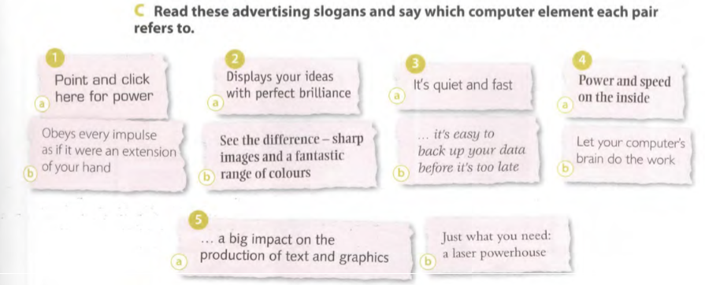

**ANSWER PART C**

1. Mouse
2. Screen
3. DVD
4. CPU
5. Printer

**ANSWER PART D**

1. To press the mouse button **Click**
2. Clear,easy to see **sharp**
3. To make an extra copy of something **Back up**
4. Selection **range**
5. Shows **display**